**DevOps**

* DevOps is a culture
* DevOps is a process
* DevOps is set of practices
* DevOps culture is used to Collaborate Development and Operations in Software Project
* Using DevOps culture we can simplify software project delivery process to clients
* DevOps is used throughout software development life cycle process

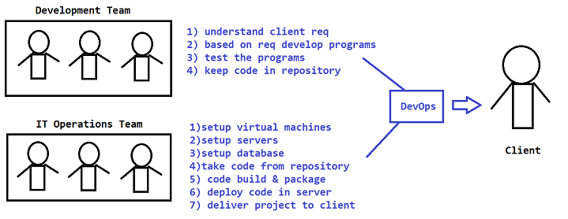

**Software Development Life Cycle (SDLC)**

* The process of developing and delivering software project is called as SDLC.

**In SDLC we have several phases:**

1) Requirements Gathering

2) Requirements Analysis

3) Design / Planning

4) Development / Coding / Implementation

5) Testing

6) Deployment

7) Maintenance

**Waterfall Methodology**

* Earlier people used to follow Waterfall Methodology to develop projects
* Waterfall is a linear methodology to develop and deliver projects
* Everything will happen step by step
* If one step completed then only we will go to next step
* We will move only in forward direction (No backward direction)
* Requirements are fixed
* Budget is fixed
* Client involvement is very less
* Client will see the project at the end

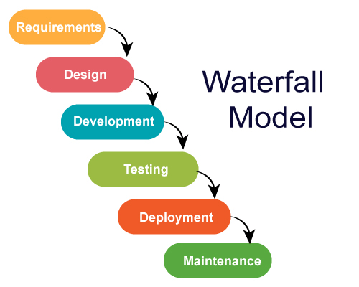

**Note:** Waterfall Methodology is not suitable for big projects

**Agile Methodology**

* Agile is an iterative approach to develop and deliver the projects
* Development and testing will happen parallelly
* Client involvement will be very high
* We will deliver project in multiple releases (Sprints)
* For every release we will take client feedback
* Requirements are not fixed
* Budget is not fixed
* Project Development, Testing & Delivery is very frequent is Agile
* Using DevOps culture we can adopt agile methodology very easily
* DevOps is promoting Agile methodology
* Using DevOps we can achieve Continuous Integration (CI) & Continuous Deployment / Delivery (CD) **CI CD**

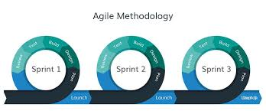

**DevOps Advantages**

1) Speed

2) Rapid Development

3) Quick Releases

4) Reliability

5) Security

6) Client Satisfaction

7) Teams Collaboration

Note: DevOps is not one person job; it is everyone's job in the project

**DevOps tools overview**

Build Tools ( Ant / Maven / Gradle )

Repository Tools (SVN / Git Hub / BitBucket )

Code Review Tools ( PMD / Sonar Qube / Sonar lint)

Code Deployment Tools ( Jenkins / UDeploy )

Containerization Tools ( Docker )

Orchestration Tools ( Kubernetes )

Configuration Tools ( Chef / Ansible )

Infrastructure as a Code (IaaC) ( Terraform)

Monitoring Tools ( Nagios / Graphana )

Project Management Tools ( Jira )